
TCA Rules of Origin -
Proof of Origin &
Supplier Declaration FAQ

Preparing for the end of easements


November 2021

Supplier Declarations FAQ

- How does an importer claim preference under the Trade and Cooperation Agreement (TCA)?
To claim preference (which means to trade with zero tariffs) in the TCA, products must meet their Product Specific Rule of Origin (PSR) outlined in the UK/EU Trade and Continuity agreement (pg.423). A PSR ensures that a product meet Rules of Origin requirements. This is achieved through one of the four most common rules under the agreement: Wholly Obtained, Change in Tariff Heading, Value Added, or Special Processing Rule.
You will need to provide evidence to support a claim for preference, using either a Statement on Origin or ‘Importer’s Knowledge’ that the product originates (which mean it meets its Rule of Origin). You may also need supplier declarations to support a claim for preferential (zero) tariffs on your goods.

- What is a supplier declaration?
Supplier declarations are used to provide evidence of the originating status of goods. They are made out by the business supplying goods or materials that will be incorporated into final goods, that are then exported, to evidence their originating status. In the event of verification by a customs authority, you may need to provide evidence from suppliers (via a supplier declaration) about the origin of your inputs.
Supplier declarations are required by an exporter when determining whether their goods qualify for preference so they can provide a Statement on Origin. Supplier declarations can also be used by an importer as part of the information required to use Importer’s Knowledge to claim preference. Supplier declarations can be verified by customs authorities as part of their checks to ensure goods met the Rules of Origin.
They can also be issued to accompany non-originating materials or goods exported from the UK to evidence any production that has taken place in the UK. Even though the goods are non-originating, the EU importer may count the UK production of these goods towards meeting the Rule of Origin for a final product. This is based on the TCA provisions allowing full bilateral cumulation. The same can be applied to materials or goods imported from the EU.

- When are supplier declarations needed?
There are occasions where manufacturing on its own is not enough to meet the Product Specific Rule of Origin, and supplier declarations are needed. For example, if:​
- any materials do not change tariff heading​
- the value of materials is over the specified limit, for example the origin rule may specify a percentage limit of 40% non-originating materials, and the total value of materials used is 45% of the ex-works price — you will then need supplier declarations to cover the value of materials in excess of the limit, that is, 5% of the ex-works price​
- you manufacture using materials at a later stage of production than the rule specifies, for example using bought-in fabric where the origin rule is manufacture from yarn​
- the only processing which you carry out on a product is considered ‘insufficient production’

- When are supplier declarations not needed?
There are certain circumstances where a supplier declaration will not be needed, for example when:​
- an origin rule specifies that all non-originating materials must change tariff heading (if during manufacture, all materials change tariff heading then the rule is met without the need for any supplier declarations)​
- a percentage rule specifies a limit on the value of non-originating materials (for example 30% or 40%. If the total value of all materials is within this limit, then the rule will be met​).
An origin rule may specify manufacture from materials at a certain stage of production, for example manufacture from yarn. if you manufacture using materials at or before the specified stage (for example pre yarn) then the rule will be met automatically.

- Where in the supply chain do supplier declarations need to come from? Is this different if there is a customs agent involved?
The exporter will source the supplier declaration from the business directly supplying them. However, that supplier may need to source information from further down the supply chain to prove the origin of their goods or inputs.
General Proof of Origin FAQ

- What evidence does an importer need to use 'Importer’s Knowledge' as proof of origin?
If the importer makes a claim for preference using Importers Knowledge, the exporter does not need to provide a statement on origin, but they may need to provide supporting documents/evidence to the importer which demonstrate the originating status of the good. This would be supporting documents or records which should cover:
- The commodity code
- A brief description of the production process (including the origin of the goods used)
- If the origin was based on ‘wholly obtained’ – give category for the goods
- If the origin was based on ‘sufficiently worked or processed’ give one of the following:
    - The value of the product as well as the value of all the non-originating or, as appropriate to establish compliance with the value requirement, originating materials used in the production
    - The weight of the product as well as the weight of the relevant non-originating or, as appropriate to establish compliance with the weight requirement, originating materials used in the product
    - A list of all the non-originating materials including their commodity code (in 2, 4 or 6-digit format depending on the origin criteria)
    - If the goods have been altered or transformed
    - Any additional information that will help verify the origin of the goods, if HMRC asks for it
If you or the person receiving your goods cannot give this information for commercial reasons you should use an origin declaration.

- Will Importer’s Knowledge end at the end of the easements on the 31st of December 2021?
No. This is a permanent feature of the TCA and as such will continue to be a route to prove origin.

- Will a statement on origin on a commercial invoice suffice as evidence of origin?
The statement on origin must be provided on an invoice, a delivery note or any other commercial document (excluding a bill of lading), describing the originating product in sufficient detail to enable its identification. The statement on origin must take the form of the text found in Annex ORIG-4 of the UK-EU TCA, an example is below:
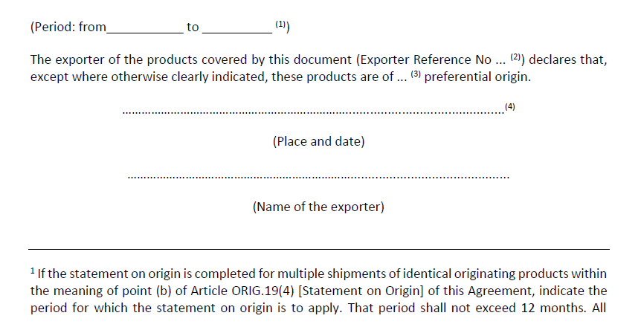

E X A M P L E

- Is the statement on origin per product or per company?
A statement on origin may apply to either:
- A single consignment
- Multiple shipments of identical products within a period specified in the statement on origin but not more than 12 months from the date of the first import
For supplier declarations, there is an option to complete a long-term supplier declaration (LTSD). This would be completed on the basis that you would receive the same consignment over a long period of time that would have the same originating status. An example can be found below:

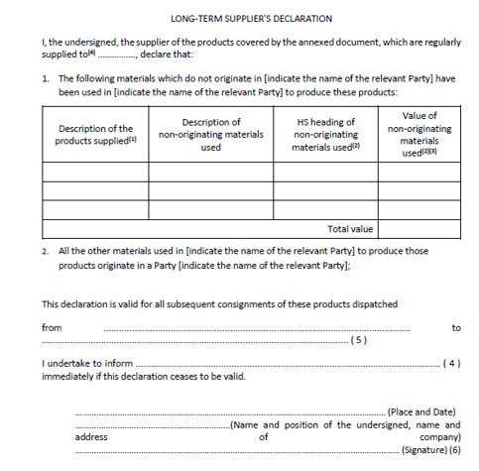

E X A M P L E

More information on supplier declarations can be found here.

